**VISVESVARAYA TECHNOLOGICAL UNIVERSITY**

“JnanaSangama”, Belgaum-18, Karnataka, India.



*A Project synopsis on*

“**DESIGN AND DEVELOPMENT OF**

**MYOELECTRIC PROSTHETIC ARM**”

*Project report Submitted in partial fulfillment of the requirement for the degree of*

**Bachelor of Engineering**

*In*

**Telecommunication Engineering**

*By*

**ADESH N A (1DS13TE008)**

8stsem B.E



**Department of Telecommunication Engineering**

**DAYANANDA SAGAR COLLEGE OF ENGINEERING**

**BANGALORE -560078.**

**ABSTRACT**

The loss of a limb can be a very traumatic experience for a person. Prosthetics are devices that can help restore some of the functionality to the user. However, without insurance, prosthetics can be very expensive, creating demand for more efficient and cheaper prosthetics. Our research uses an Arduino microcontroller to design a myoelectric prosthetic, a prosthetic that reads electrical signals from the residual limb and powers motors for movement.

**INTRODUCTION**

There are over an estimated 100,000 upper extremity amputees currently living in India alone. Many of those people could benefit from the psychological gains and physical usefulness of a simple powered prosthesis. It is a sad fact that people who are viewed as “different” in our society stand out, but those people simply want to blend in and be treated normally, and be able to lead normal high functioning lives. Amputees are strong and capable people, who make do with what they have, and are able to overcome adversity. There is room for improvement in all aspects of current prosthetic technology relating to mechanical design, electrical signal processing, and overall system performance. There are not a large number of major companies developing competing products because the market is still quite small and limited from a business perspective.



This is an early prosthetic hook and socket created during the Civil War. Modern prosthetic hooks remain very similar aesthetically and it is time to move into the 21st century.

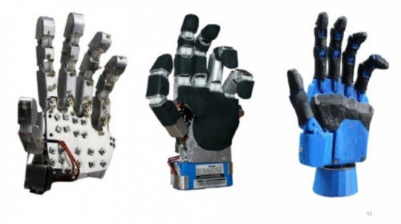 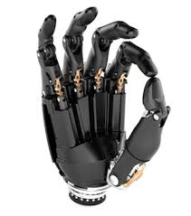

Affordable 3D printed prosthetic arm Modern bionic hand

**LITERATURE SURVEY**

1. Dustin J. Tyler | April 23,2016. This paper explores the advances that have happened in this field and gives us a lot of information about the present technology that is being used for prosthesis. Also the author hopes to engineer a process that would make the amputee feel like he has the same arm that was lost. The paper discusses about the loss of movements, sensory impulses and the way to get them back using the advancing technology and implementing it in prosthesis. The paper also discusses about the placing of the electrodes in the muscles.

2. [SilvestroMicera](http://pulse.embs.org/author/smicera/) |May 23, 2016. This paper discusses about the number of people facing the problems of amputation due to various reasons and gives us an idea about the basics of the myoelectric prosthesis and its types. The author talks about the Degrees of freedom provided by the current technology prosthetic limbs which are less in number and tell that due to the lack of many degrees of freedom leads to considering the limb as a foreign body. Also the author points out giving sensory feedback to the system usingtargeted muscle reinnervation (TMR).

3. [Kathy Pretz](http://theinstitute.ieee.org/author/pretz-kathy) |19 December 2016. Discussing the various topics related to the myoelectric prosthesis by authors like IEEE Senior Member Yu Yuan, IEEE Senior Member Christian Cipriani, IEEE Member Levi Hargrove, IEEE Member Conor Walsh, and the paper has the views of these authors. It also explores how this technology was thought as a science-fiction and how it has been turned into reality. It gives us brief view on the present technology, the proposed systems of the authors and the future of these proposed systems.

4. Carlos M. Oppus| Date of Conference: 22-25 Nov. 2016Designs for 3D printed hand prosthetics are only capable of basic hand gestures given their fully mechanical structure. That said, the purpose of this thesis is to give users greater flexibility and control over 3D printed hand prosthetics by modifying and improving existing open-source prosthetics models. This will be accomplished by integrating two control modules with the 3D printed prosthetic hand - (a) a brain-computer interface, and (b) a voice recognition module - which will serve as its two primary modes of control.

**PROBLEM SOLUTION**

1. One of the main problems faced in the field of robotic prosthetic limbs is the high cost of the product, as using implants or brain-computer interface may not be feasible for everyone.

For this reason using an EMG sensor makes the product more economical, although using implants provides better accuracy and allows separate finger control.

2. An easy interface for each finger movement control and pre programmed presets allows the user to control the prosthetic arm from an android application rather than using voice recognition or computer interface, thereby reducing the complexity in the design and again making the product more economical.

3. To further cut down the cost, 3D printed arm is used instead of metal alloys as shown in the diagram “Modern bionic arm” and also making the prosthetic arm much lighter.

But the durability of a 3D printed arm is comparatively lesser.

**DESIGN REQUIREMENTS**

**User Interface** **:**

1. Hand will be safe to use and handle during operation
2. There will be covers or a shell over all components for protection from common impacts
3. Batteries will be easily swappable or rechargeable with 1 hand and no additional tools

**Human Form Factor/Appearance :**

1. Will resemble the general form of an adult human hand
2. Entire hand will weigh around 450g including self-contained power and control
3. Hand will consist of 6 servos/actuators, 5 individually actuated fingers, plus thumb roll

**Control and Sensor Integration :**

1. Fingers will be driven by several servos
2. Sensitive EMG sensors and gyro sensors along with amplifiers are used to detect motions from the hand.
3. There will be a commonly available standard microprocessor able to handle sensor inputs and motor outputs, for example an Arduino nano or equivalent.

**Manufacturability :**

1. Design will utilize a 3D printed arm made of bio degradable plastic.
2. Entire cost to manufacture and assemble one complete arm will be less than ₹20,000 at quantity (1x).

**Safety/Failsafe Conditions :**

1. If input control signal is lost, all actuators and motion will stop.
2. If the battery is running low, the LEDs will signal the user for recharging.

**Mechanical design :**

Detailed mechanical design is accomplished through the use of rough hand drawn sketches and 3Ds Max software by Autodesk. Backup data and part files of the design can be made available.

**PROPOSED SYSTEM**

The pulses or action potential which is caused by the contraction or relaxation of the posterior and anterior muscles of the forearm is sensed by the electrodes of the myo sensors. These muscle sensors works on the principle of EMG(Electromyography) or just Myography.

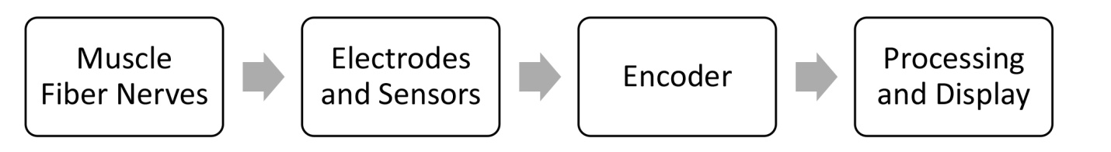

Process of electro myography

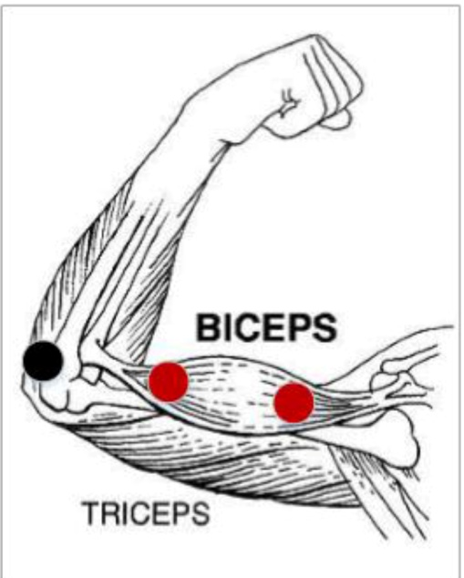 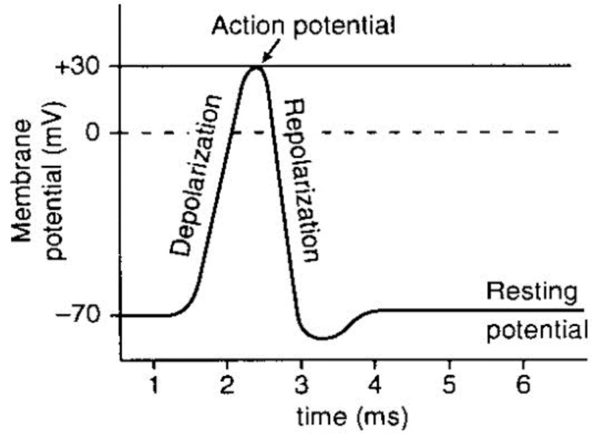

EMG electrode placement The stages of an action potential.

The output of which is a voltage. This voltage is further amplified by the amplifier which is internal to the muscle sensor or may be included after the sensor depending on the sensor specifications. The amplified output is given to the microcontroller that takes the voltages and compares it with the voltages given and drives the servo motors/actuators depending on the result of the comparison.

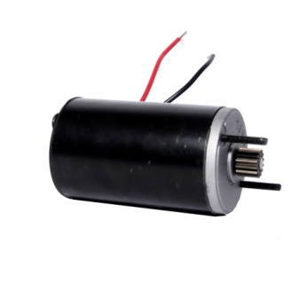 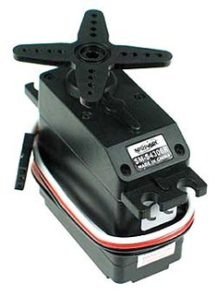

**Motor selection :** Proper motor selection is an important aspect of this design because all degrees of freedom could be powered by the same type of motor. A range of different motors will be compared based on their speed and torque in addition to their size and cost/availability.

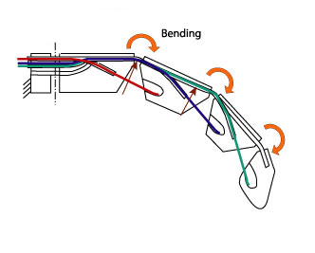 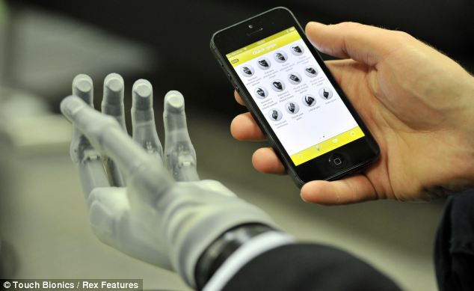 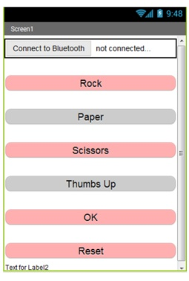

Wiring technique used for fingers App interface to control prosthetic arm

The servo motors/actuators which are tied with shock wires connected to each finger or may include three separate wires for each finger for better grip and accuracy as shown in the above figure, design is made in such a way that it does not include any wires connecting from the sensors to the arm(wireless), making it more user friendly.

The prosthetic arm can also be controlled wirelessly by a remote or through an android app, which includes preset patterns.

**METHODOLOGY**

1. At first all the electrodes from the muscle sensor are attached to the various sections of the residual arm as shown in the above diagram “EMG electrode placement”.

2. Based on the movements of the residual arm, contractions and expansion of the muscles are detected by the EMG sensor through the electrodes attached to the arm.

3. The EMG sensor is connected to the microcontroller,

On the basics of values received from the sensor by expansion and contractions of muscles, a code is written and fed into the microcontroller to control various servos(finger movements)

4. A Bluetooth module is used to provide interfacing with an android device to perform various preset functions by the prosthetic arm, as show in the diagram “App interface to control prosthetic arm”

5. Each of the servo connected to the microcontroller, controls each finger (totally five fingers) of the prosthetic arm, which in turn depends on the signals received from the sensor

6. The prosthetic arm used here will be a 3D printed arm whose design structure is as shown in the diagram “Wiring technique used for fingers” and “3D printed prosthetic arm”

**SOFTWARES TOOLS USED**

1. virtual simulators are used for designing the circuit.

2. Flashing tools

3. Autodesk AutoCad and 3Ds Max are the softwares used for designing of the prosthetic arm.

4.Eclipse is used for android app development.

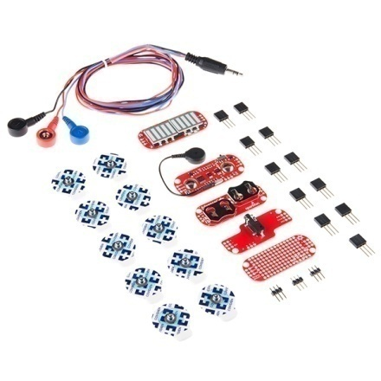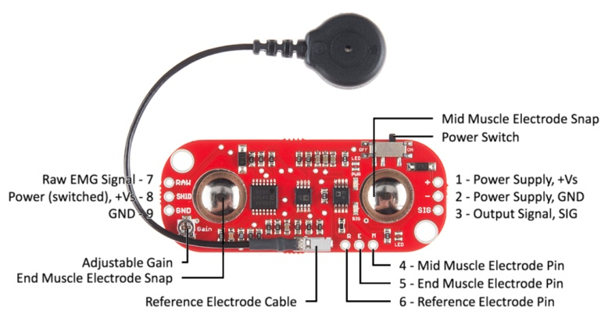

An EMG muscle sensor, along with several connectors and shield.

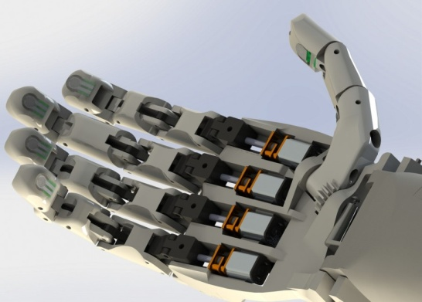 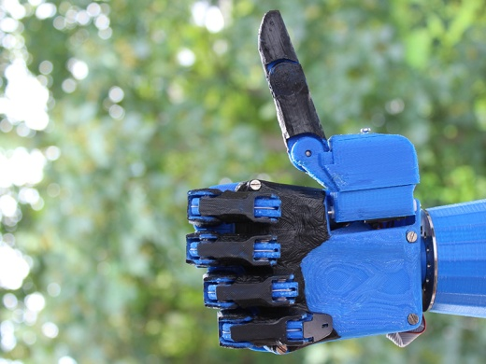

3D printed arm based on requirement

**CONCLUSION**

Overall, the project shows how versatile Arduino can be. The concept behind the project is that, using the principles of bionics and embedded systems we can provide a cheap and effective way to create or tweak a myoelectric prosthetic.